به نام خداوند جان و خرد



**معاونت پژوهش و فناوری**

**دانشکده ؟؟؟؟- گروه ؟؟؟؟**

**گزارش طرح پژوهشی**

**عنوان طرح نوشته شود (بی تیتر 14 بولد؛ تایمز 14 بولد، نام­های علمی ایتالیک)**

**مجری طرح:**

احمد احمدی

**همکاران طرح:**

محمد محمدی

حسین حسینی

**تابستان 1404**

**شناسنامه طرح**

**معاونت پژوهش و فناوری**

**دانشکده ؟؟؟؟- گروه ؟؟؟؟**

**1- عنوان:** عنوان نوشته شود (بی زر 12؛ تایمز 10)

**2- مجری طرح:** احمد احمدی

**3- همکاران طرح:** محمد محمدی و حسین حسینی

**4- ناظر طرح:** جواد جوادی

**5- اعتبار طرح:** 187/053/19 ریال

**6- محل تامین اعتبار:** از محل اعتبارات پژوهشی دانشگاه علوم کشاورزی و منابع طبیعی گرگان

**7- تصویب:** پیشنهادیه طرح در جلسه ؟؟؟ مورخ ؟؟/؟؟/؟؟14 شورای پژوهشی و فناوری دانشگاه به تصویب رسید.

**8- اختتام:** گزارش نهایی طرح در جلسه ..............مورخ .............. شورای پژوهش و فناوری دانشگاه به تصویب رسید.

**9- شماره شناسه طرح:** 49-490-02

**مسئولیت صحت مطالب مندرج در این گزارش بر عهده مجری طرح می‏باشد**.

**عنوان مقاله دوم**

**چکیده**

چکیده نوشته شود (بی لوتوس یا بی زر 12؛ تایمز 10؛ نام­های علمی ایتالیک شوند)

**واژه­های کلیدی:** ؟؟؟؟، ؟؟؟؟؟، ؟؟؟؟؟، ؟؟؟؟؟؟؟ (بی لوتوس یا بی زر 11).

**چکیده این گزارش در سایت معاونت پژوهش و فناوری دانشگاه در آدرس [www.gau.ac.ir](http://www.gau.ac.ir) قابل دسترس می‏باشد.**

**عنوان مقاله سوم**

**چکیده**

چکیده نوشته شود (بی لوتوس یا بی زر 12؛ تایمز 10؛ نام­های علمی ایتالیک شوند)

**واژه­های کلیدی:** ؟؟؟؟، ؟؟؟؟؟، ؟؟؟؟؟، ؟؟؟؟؟؟؟ (بی لوتوس یا بی زر 11).

**چکیده این گزارش در سایت معاونت پژوهش و فناوری دانشگاه در آدرس [www.gau.ac.ir](http://www.gau.ac.ir) قابل دسترس می‏باشد.**

**Contents**

**Title Page**

**فصل اول: عنوان مقاله**

1-1- چکیده ..................................................................................................................................................... 1

2-1- مقدمه ....................................................................................................................................................... 2

3-1- مواد و روش­ها ......................................................................................................................................... 3

1-3-1- عنوان فرعی ......................................................................................................................................... 3

1-1-3-1- عنوان فرعی فرعی .......................................................................................................................... 4

2-3-1- عنوان فرعی ....................................................................................................................................... 4

4-1- نتایج و بحث ........................................................................................................................................... 4

5-1- نتیجه­گیری کلی ...................................................................................................................................... 4

6-1- منابع ......................................................................................................................................................... 4

**Chapter two: Title of paper**

2.1. Abstract .................................................................................................. 6

2.2. Introduction ............................................................................................ 6

2.3. Materials and Methods .......................................................................... 7

2.3.1. Subtitle ................................................................................................ 7

2.3.1.1. Sub-subtitle ...................................................................................... 7

2.3.1.2. Sub-subtitle ...................................................................................... 7

2.3.2. Subtitle ................................................................................................ 8

2.4. Results and Discussion .......................................................................... 8

2.5. Conclusions ............................................................................................ 4

2.6. References .............................................................................................. 5

**Chapter three: Title of paper**

3.1. Abstract .................................................................................................. 6

3.2. Introduction ............................................................................................ 6

3.3. Materials and Methods .......................................................................... 7

3.3.1. Subtitle ................................................................................................ 7

3.3.1.1. Sub-subtitle ...................................................................................... 2

3.3.1.2. Sub-subtitle ...................................................................................... 7

3.3.2. Subtitle ................................................................................................ 8

3.4. Results and Discussion .......................................................................... 8

3.5. Conclusions ............................................................................................ 4

3.6. References .............................................................................................. 5

**List of Tables**

**Title Page**

Table 1.1. list of 52 alien plants in Iran and their main characteristics ...... 25

Table 1.2. Common management methods for alien plants ...................... 28

Table 2.1. Common management methods for alien plants ...................... 28

Table 2.2. Common management methods for alien plants ...................... 28

Table 3.1. Common management methods for alien plants ...................... 28

Table 3.2. Common management methods for alien plants ...................... 28

**List of Figures**

**Title Page**

Figure 1.1. Alien plants categorized as invasive, perennial and annual alien plants ........................................................................................................... 32

Figure 1.2. Number of alien plant species according their invasive status in different habitats in Iran .............................................................................. 40

Figure 1.3. The distribution of 52 alien plants in Iran and their invasion status with mean GISS score for each ecological zone .............................. 45

Figure 2.1. Alien plants categorized as invasive, perennial and annual alien plants ........................................................................................................... 32

Figure 2.2. Number of alien plant species according their invasive status in different habitats in Iran .............................................................................. 40

Figure 2.3. The distribution of 52 alien plants in Iran and their invasion status with mean GISS score for each ecological zone .............................. 45

Figure 3.1. Alien plants categorized as invasive, perennial and annual alien plants ........................................................................................................... 32

Figure 3.2. Number of alien plant species according their invasive status in different habitats in Iran .............................................................................. 40

Figure 3.3. The distribution of 52 alien plants in Iran and their invasion status with mean GISS score for each ecological zone .............................. 45

**فصل اول- عنوان مقاله (با فرض 1 مقاله فارسی و دو مقاله انگلیسی)**

(5 سطر فاصله با اولین عنوان اصلی درج شود)

**1-1- چکیده (بی لوتوس 13 بولد؛ تایمز 11 بولد)**

مطالب ذیل عنوان نوشته شوند (بی زر 12؛ تایمز 10؛ نام­های لاتین ایتالیک باشند). گندم (*Triticum aestivum* L.) یکی از مهم­ترین منابع غذایی مردم جهان محسوب می­شود به طوری که حدود 18 درصد از کالری و 19 درصد از پروتئین مورد نیاز بشر از این غله تامین می­گردد.

(فقط یک سطر فاصله با پاراگراف بعدی درج شود)

**2-1- مقدمه**

مطالب ذیل عنوان نوشته شوند (بی زر 12؛ تایمز 10؛ نام­های لاتین ایتالیک باشند).

**3-1- مواد و روش­ها**

مطالب ذیل عنوان نوشته شوند (بی زر 12؛ تایمز 10؛ نام­های لاتین ایتالیک باشند).

**1-3-1- زیرعنوان (بی لوتوس 12 بولد؛ تایمز 10 بولد)**

مطالب ذیل عنوان نوشته شوند (بی زر 12؛ تایمز 10؛ نام­های لاتین ایتالیک باشند). گندم[1] یکی از مهم­ترین منابع غذایی مردم جهان محسوب می­شود به طوری که حدود 18 درصد از کالری و 19 درصد از پروتئین[2] مورد نیاز بشر از این غله تامین می­گردد.

1-1-3-1-  **زیرزیرعنوان (بی لوتوس 12 بولد؛ تایمز 10 بولد)**

مطالب ذیل عنوان نوشته شوند (بی زر 12؛ تایمز 10؛ نام­های لاتین ایتالیک باشند). گندم یکی از مهم­ترین منابع غذایی مردم جهان محسوب می­شود به طوری که حدود 18 درصد از کالری و 19 درصد از پروتئین مورد نیاز بشر از این غله تامین می­گردد.

**2-3-1- زیرعنوان (بی لوتوس 12 بولد؛ تایمز 10 بولد)**

مطالب ذیل عنوان نوشته شوند (بی زر 12؛ تایمز 10؛ نام­های لاتین ایتالیک باشند). گندم[3] یکی از مهم­ترین منابع غذایی مردم جهان محسوب می­شود به طوری که حدود 18 درصد از کالری و 19 درصد از پروتئین[4] مورد نیاز بشر از این غله تامین می­گردد.

**4-1- نتایج و یحث**

**جدول 1-3- (عنوان شکل و جدول: بی لوتوس 10 بولد؛ بی تایمز 8 بولد؛ نام­های علمی ایتالیک) میانگین (± خطای معیار) چند ویژگی‌ مهم زیستی و دموگرافیک شته *S. graminum* روی بوته‌های سه رقم مختلف گندم.**

|  |  |  |  |  |  |
| --- | --- | --- | --- | --- | --- |
| **نرخ ذاتی رشد جمعیت** | **زادآوری شته‌های ماده (پوره/ ماده)** | **میانگین طول یک نسل (*T*)**  **(روز)** | **طول عمر**  **شته­های ماده**  **(روز)** | **طول دوره پورگی**  **(روز)** | **رقم** |
| 245/0 ±011/0 c | 35/17 ±33/2 c | 59/11 ±26/0 a | 66/13 ±37/1 b | 61/6 ±12/0 a | آسمان |
| 348/0 ±009/0 b | 64/40 ±18/4 b | 46/10 ±27/0 c | 18/16 ±41/1 b | 81/5 ±13/0 b | مروارید |
| 385/0 ±007/0 a | 71/73 ±91/1 a | 17/11 ±21/0 b | 27/25 ±5/1 a | 99/5 ±12/0 ab | کوهدشت |

*میانگین‌های دارای حروف متفاوت در هر ستون، با یکدیگر اختلاف معنی­دار دارند (*P*< 0.05, Paired bootstrap test).

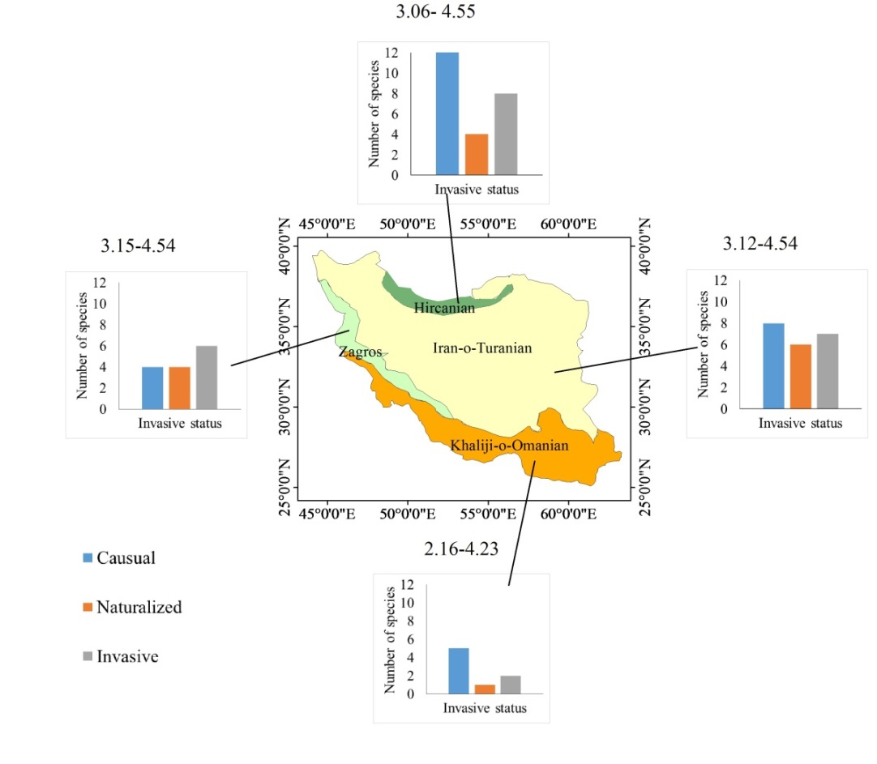

**شکل 1-3- (عنوان شکل و جدول: بی لوتوس 10 بولد؛ بی تایمز 8 بولد؛ نام­های علمی ایتالیک) میانگین (± خطای معیار) چند ویژگی‌ مهم زیستی و دموگرافیک شته *S. graminum* روی بوته‌های سه رقم مختلف گندم (اصلی).**

**5-1- نتیجه­گیری کلی**

**6-1- منابع**

**Chapter two: Title of paper**

**2.1 Abstract**

The greenbug, *Schizaphis graminum* (Rondani), is one of the major pests of wheat worldwide. Due to the environmental and health consequences of pesticide, the use of "induced resistance" as a biorational method in integrated pest management has been greatly developed in recent years.

**Keywords:** *Schizaphis graminum*, Wheat, Induced resistance.

**2.2. Introduction**

In the last decade, there has been increased evidence about the negative impacts of alien species on the environment, the economy and human well-being in all parts of the world (Vilà *et al*., 2011; Rumlerová *et al*., 2016; Nentwig *et al*., 2018). Providing data about the current status and distribution of problematic alien plants is essential for reducing significant adverse impacts (Simberloff, 2013; Pyšek *et al*., 2020; Gallardo *et al*., 2019; Sohrabi *et al*., 2020).

**2.3. Materials and Methods**

In the last decade, there has been increased evidence about the negative impacts of alien species on the environment, the economy and human well-being in all parts of the world (Vilà *et al*., 2011; Rumlerová *et al*., 2016; Nentwig *et al*., 2018). Providing data about the current status and distribution of problematic alien plants is essential for reducing significant adverse impacts (Simberloff, 2013; Pyšek *et al*., 2020; Gallardo *et al*., 2019; Sohrabi *et al*., 2020).

**2.3.1. Subtitle**

In the last decade, there has been increased evidence about the negative impacts of alien species on the environment, the economy and human well-being in all parts of the world (Vilà *et al*., 2011; Rumlerová *et al*., 2016; Nentwig *et al*., 2018). Providing data about the current status and distribution of problematic alien plants is essential for reducing significant adverse impacts (Simberloff, 2013; Pyšek *et al*., 2020; Gallardo *et al*., 2019; Sohrabi *et al*., 2020).

**2.3.1.1. Sub-subtitle**

In the last decade, there has been increased evidence about the negative impacts of alien species on the environment, the economy and human well-being in all parts of the world (Vilà *et al*., 2011; Rumlerová *et al*., 2016; Nentwig *et al*., 2018). Providing data about the current status and distribution of problematic alien plants is essential for reducing significant adverse impacts (Simberloff, 2013; Pyšek *et al*., 2020; Gallardo *et al*., 2019; Sohrabi *et al*., 2020).

**2.3.1.2. Sub-subtitle**

In the last decade, there has been increased evidence about the negative impacts of alien species on the environment, the economy and human well-being in all parts of the world (Vilà *et al*., 2011; Rumlerová *et al*., 2016; Nentwig *et al*., 2018). Providing data about the current status and distribution of problematic alien plants is essential for reducing significant adverse impacts (Simberloff, 2013; Pyšek *et al*., 2020; Gallardo *et al*., 2019; Sohrabi *et al*., 2020).

**2.3.2. Subtitle**

In the last decade, there has been increased evidence about the negative impacts of alien species on the environment, the economy and human well-being in all parts of the world (Vilà *et al*., 2011; Rumlerová *et al*., 2016; Nentwig *et al*., 2018). Providing data about the current status and distribution of problematic alien plants is essential for reducing significant adverse impacts (Simberloff, 2013; Pyšek *et al*., 2020; Gallardo *et al*., 2019; Sohrabi *et al*., 2020).

**2.4. Results and Discussion**

In the last decade, there has been increased evidence about the negative impacts of alien species on the environment, the economy and human well-being in all parts of the world (Vilà *et al*., 2011; Rumlerová *et al*., 2016; Nentwig *et al*., 2018). Providing data about the current status and distribution of problematic alien plants is essential for reducing significant adverse impacts (Simberloff, 2013; Pyšek *et al*., 2020; Gallardo *et al*., 2019; Sohrabi *et al*., 2020).

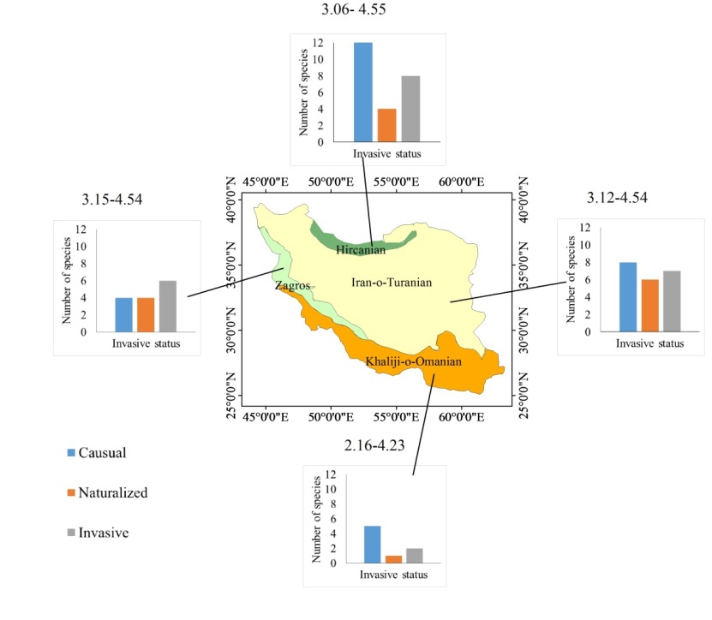

**Figure 2.1. The distribution of 52 alien plants in Iran and their invasion status. The numbers above each graph are mean GISS score (min-max) for each ecological zone (Original).**

**Table 2.1. Common management methods for alien plants, * indicate alien plants with high impact score (> 4) and species that receive management in Iran are highlighted in bold.**

|  |  |  |  |  |
| --- | --- | --- | --- | --- |
| **Plant species** | **Chemical control** | **Other Control Methods (mechanical or physical and cultural control)** | **management recommendations** | **References** |
| *Eichhornia crassipes\** | Bispyribac sodium | Cutting and collecting | Combination of biological and physical control | Yaghoubi et al. 2020; Karouach et al. 2022 |
| *Ailanthus altissima \** | Systemic herbicide injection | Cutting | Stem injection | Brundu 2017 |
| *Eupatorium cannabinum* | Systemic herbicdes | Manual removal | Manual removal | http://www.iucngisd.org |
| *Imperata cylindrica \** | Glyphosate | Moving | Combination of chemical and physical control | Zand et al. 2017; Eskandari, et al. 2020 |
| *Pueraria montana var. lobata \** | Systemic herbicdes | Cutting and collecting | Thermal treatment | http://www.iucngisd.org |
| *Amsinckia menziesii \** | 2,4-D and MCPA | Hand weeding | Chemical control | Sajedi et al. 2012; Zand et al. 2017 |

**2.5. Conclusions**

In Iran there are more than 20 alien plant species with high impact based on GISS. The highest environmental and socioeconomic impacts are reported for perennial alien plants like *Eichhornia crassipes, Imperata cylindrica* and *Cynanchum acutum* that invade wetlands and agricultural lands. *Ailanthus altissima*, *Pueraria montana* var. *lobata* and *Fallopia japonica* occur in urban areas and forests. Applying more restrictions to importing new plants specifically in the Hircanian zone is essential. Hircanian forests, which are known as the wet or Caspian forests, have high environmental and economic values. These forests are a World National Heritage site (https://whc.unesco.org) and should also be considered a potential hotspot for biological invasion in Iran.

**Acknowledgements:** Gorgan University of Agricultural Sciences and Natural Resources (GUASNR), Iran supported this research (project No: 94-666-20).

**2.6. References**

**Chapter three: Title of paper**

**3.1 Abstract**

The greenbug, *Schizaphis graminum* (Rondani), is one of the major pests of wheat worldwide. Due to the environmental and health consequences of pesticide, the use of "induced resistance" as a biorational method in integrated pest management has been greatly developed in recent years.

**Keywords:** *Schizaphis graminum*, Wheat, Induced resistance.

**3.2. Introduction**

In the last decade, there has been increased evidence about the negative impacts of alien species on the environment, the economy and human well-being in all parts of the world (Vilà *et al*., 2011; Rumlerová *et al*., 2016; Nentwig *et al*., 2018). Providing data about the current status and distribution of problematic alien plants is essential for reducing significant adverse impacts (Simberloff, 2013; Pyšek *et al*., 2020; Gallardo *et al*., 2019; Sohrabi *et al*., 2020).

**3.3. Materials and Methods**

In the last decade, there has been increased evidence about the negative impacts of alien species on the environment, the economy and human well-being in all parts of the world (Vilà *et al*., 2011; Rumlerová *et al*., 2016; Nentwig *et al*., 2018). Providing data about the current status and distribution of problematic alien plants is essential for reducing significant adverse impacts (Simberloff, 2013; Pyšek *et al*., 2020; Gallardo *et al*., 2019; Sohrabi *et al*., 2020).

**3.3.1. Subtitle**

In the last decade, there has been increased evidence about the negative impacts of alien species on the environment, the economy and human well-being in all parts of the world (Vilà *et al*., 2011; Rumlerová *et al*., 2016; Nentwig *et al*., 2018). Providing data about the current status and distribution of problematic alien plants is essential for reducing significant adverse impacts (Simberloff, 2013; Pyšek *et al*., 2020; Gallardo *et al*., 2019; Sohrabi *et al*., 2020).

**3.3.1.1. Sub-subtitle**

In the last decade, there has been increased evidence about the negative impacts of alien species on the environment, the economy and human well-being in all parts of the world (Vilà *et al*., 2011; Rumlerová *et al*., 2016; Nentwig *et al*., 2018). Providing data about the current status and distribution of problematic alien plants is essential for reducing significant adverse impacts (Simberloff, 2013; Pyšek *et al*., 2020; Gallardo *et al*., 2019; Sohrabi *et al*., 2020).

**3.3.1.2. Sub-subtitle**

In the last decade, there has been increased evidence about the negative impacts of alien species on the environment, the economy and human well-being in all parts of the world (Vilà *et al*., 2011; Rumlerová *et al*., 2016; Nentwig *et al*., 2018). Providing data about the current status and distribution of problematic alien plants is essential for reducing significant adverse impacts (Simberloff, 2013; Pyšek *et al*., 2020; Gallardo *et al*., 2019; Sohrabi *et al*., 2020).

**3.3.2. Subtitle**

In the last decade, there has been increased evidence about the negative impacts of alien species on the environment, the economy and human well-being in all parts of the world (Vilà *et al*., 2011; Rumlerová *et al*., 2016; Nentwig *et al*., 2018). Providing data about the current status and distribution of problematic alien plants is essential for reducing significant adverse impacts (Simberloff, 2013; Pyšek *et al*., 2020; Gallardo *et al*., 2019; Sohrabi *et al*., 2020).

**3.4. Results and Discussion**

In the last decade, there has been increased evidence about the negative impacts of alien species on the environment, the economy and human well-being in all parts of the world (Vilà *et al*., 2011; Rumlerová *et al*., 2016; Nentwig *et al*., 2018). Providing data about the current status and distribution of problematic alien plants is essential for reducing significant adverse impacts (Simberloff, 2013; Pyšek *et al*., 2020; Gallardo *et al*., 2019; Sohrabi *et al*., 2020).



**Figure 3.1. The distribution of 52 alien plants in Iran and their invasion status. The numbers above each graph are mean GISS score (min-max) for each ecological zone (Original).**

**Table 3.1. Common management methods for alien plants, * indicate alien plants with high impact score (> 4) and species that receive management in Iran are highlighted in bold.**

|  |  |  |  |  |
| --- | --- | --- | --- | --- |
| **Plant species** | **Chemical control** | **Other Control Methods (mechanical or physical and cultural control)** | **management recommendations** | **References** |
| *Eichhornia crassipes\** | Bispyribac sodium | Cutting and collecting | Combination of biological and physical control | Yaghoubi et al. 2020; Karouach et al. 2022 |
| *Ailanthus altissima \** | Systemic herbicide injection | Cutting | Stem injection | Brundu 2017 |
| *Eupatorium cannabinum* | Systemic herbicdes | Manual removal | Manual removal | http://www.iucngisd.org |
| *Imperata cylindrica \** | Glyphosate | Moving | Combination of chemical and physical control | Zand et al. 2017; Eskandari, et al. 2020 |
| *Pueraria montana var. lobata \** | Systemic herbicdes | Cutting and collecting | Thermal treatment | http://www.iucngisd.org |
| *Amsinckia menziesii \** | 2,4-D and MCPA | Hand weeding | Chemical control | Sajedi et al. 2012; Zand et al. 2017 |

**3.5. Conclusions**

In Iran there are more than 20 alien plant species with high impact based on GISS. The highest environmental and socioeconomic impacts are reported for perennial alien plants like *Eichhornia crassipes, Imperata cylindrica* and *Cynanchum acutum* that invade wetlands and agricultural lands. *Ailanthus altissima*, *Pueraria montana* var. *lobata* and *Fallopia japonica* occur in urban areas and forests. Applying more restrictions to importing new plants specifically in the Hircanian zone is essential. Hircanian forests, which are known as the wet or Caspian forests, have high environmental and economic values. These forests are a World National Heritage site (https://whc.unesco.org) and should also be considered a potential hotspot for biological invasion in Iran.

**Acknowledgements:** Gorgan University of Agricultural Sciences and Natural Resources (GUASNR), Iran supported this research (project No: 94-666-20).

**3.6. References**

**Title of paper 1**

**Abstract**

Times New Roman 11. The greenbug, *Schizaphis graminum* (Rondani), is one of the major pests of wheat worldwide. Due to the environmental and health consequences of pesticide, the use of "induced resistance" as a biorational method in integrated pest management has been greatly developed in recent years.

**Keywords:** *Schizaphis graminum*, Wheat, Induced resistance, Times New Roman 10.



Gorgan University of Agricultural

Sciences and Natural Resources

Vice Presidency for Research and Technology

Faculty of ????-Department of ????

**Research Report**

**Induced resistance of three varieties of wheat (*Triticum aestivum* L.) against the greenbug aphid, *Schizaphis graminum* Rondai (Hem.: Aphididae)**

**By:**

Ahmad ahmadi

**Co-Workers:**

Mohammad Mohammadi

Hossein Hosseini

**Summer 2025**

1. . Wheat
2. . Protein
3. . Wheat
4. . Protein